Home Schooling 43
TODAY WE’RE PRACTICING HAVE GOT WITH A SONG!
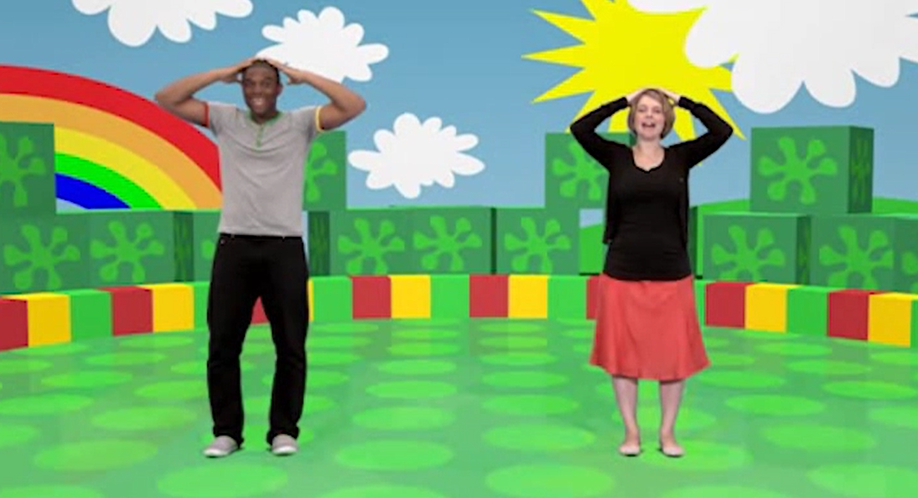
NOW GO ONLINE

CTRL+CLICK AND WORK ONLINE:
https://forms.gle/y2hpB3n4JfMoBzfT6
PLEASE PRESS “SUBMIT/SEND” AT THE END OF YOUR ONLINE WORK
POR FAVOR PRESIONAR “ENVIAR” AL FINAL DEL TRABAJO EN LINEA

