Home Schooling 72
TODAY WE’RE PRACTICING WHAT WE KNOW!
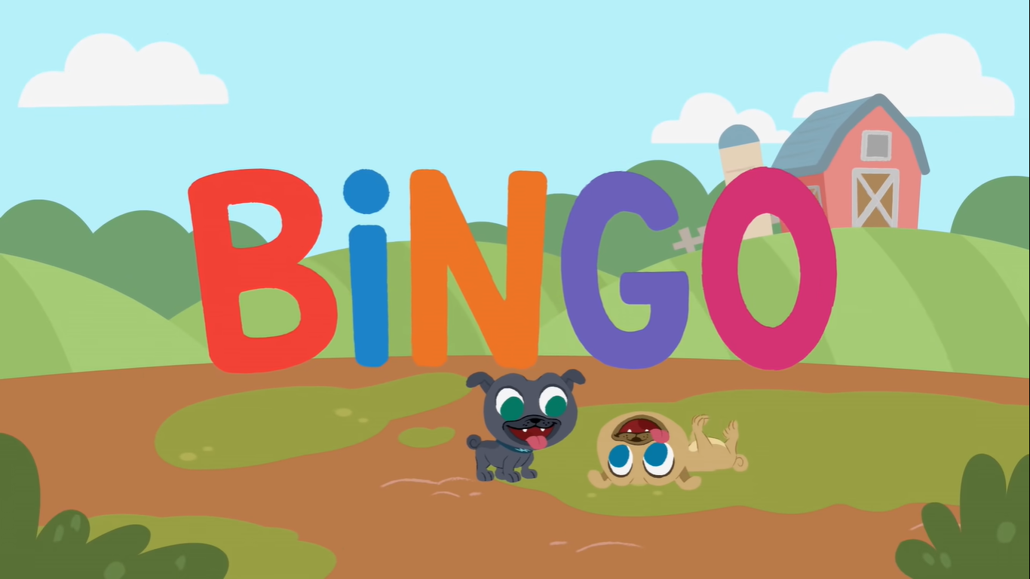

NOW GO ONLINE

CTRL+CLICK AND WORK ONLINE:
https://forms.gle/EydhBUi28wsMHXQ26
PLEASE PRESS “SUBMIT/SEND” AT THE END OF YOUR ONLINE WORK
POR FAVOR PRESIONAR “ENVIAR” AL FINAL DEL TRABAJO EN LINEA

