Name:…
Surname: …
Home Schooling 32

*HI KIDS! TODAY WE’RE BEGINNING A NEW UNIT!

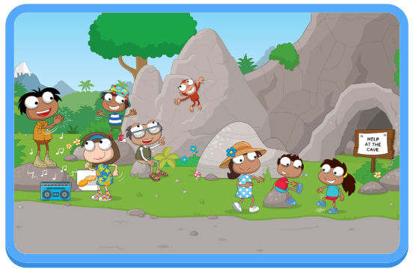

WE’RE LEARNING WORDS FOR BODY MOVEMENTS.

DO YOU REMEMBER THE PARTS OF THE BODY?
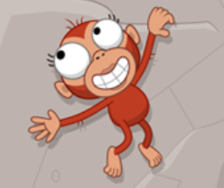
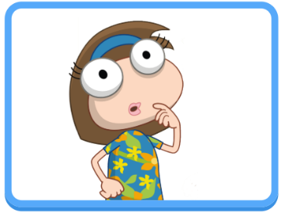

WHAT ENGLISH WORDS DO YOU KNOW FOR ACTIONS?

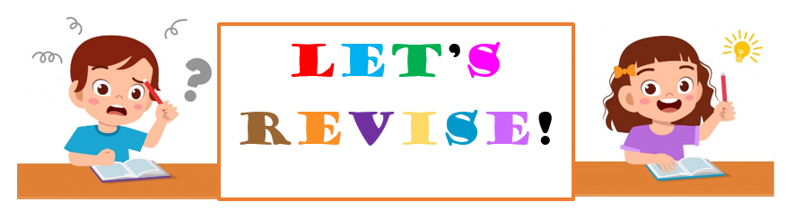

NOW GO ONLINE

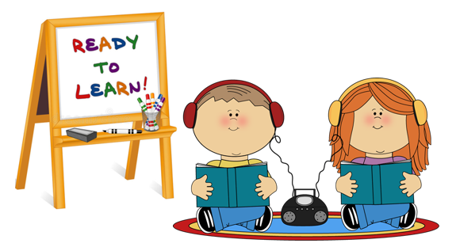

CTRL + CLICK AND WORK ONLINE.
PART A: https://forms.gle/QGjU4piyrK4CMBRz8
PART B: https://forms.gle/AcHYBp3wosBoAzY96

PLEASE, PRESS “SUBMIT/SEND” AT THE END OF YOUR ONLINE WORK.
POR FAVOR PRESIONAR “ENVIAR” AL FINAL DEL TRABAJO EN LÍNEA.

