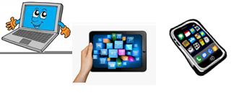
Name: …
Surname: …
Home Schooling 54

NOW GO ONLINE

CTRL+ CLICK TO GO ONLINE
https://forms.gle/8jYPMnijufb79zVZ9
PLEASE PRESS “SUBMIT/SEND” AT THE END OF YOUR ONLINE WORK.
POR FAVOR PRESIONAR “ENVIAR” AL FINAL DEL TRABAJO EN LINEA.

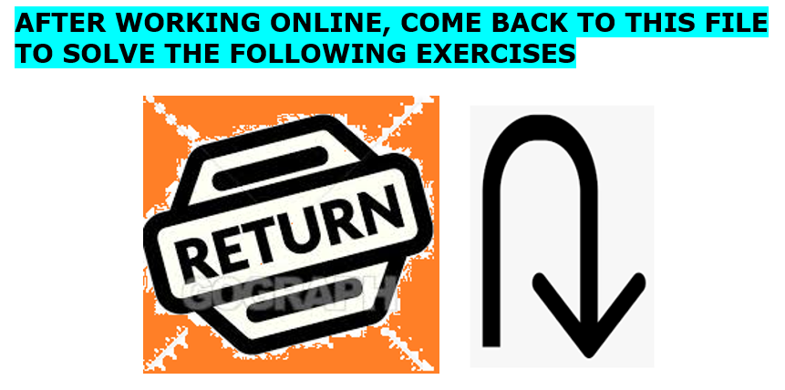

LOOK!
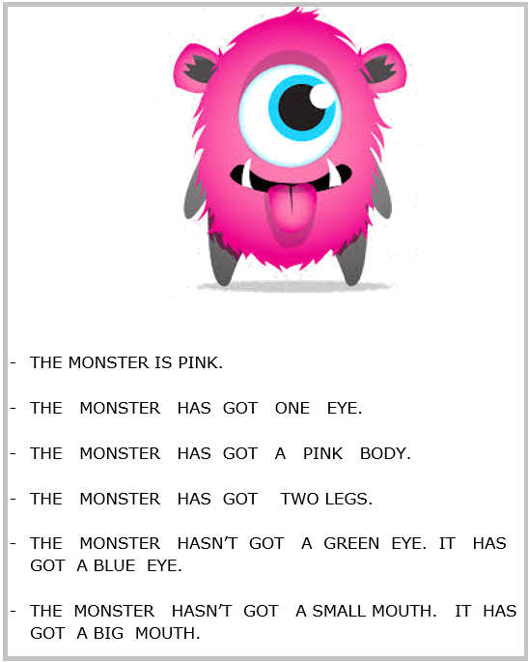

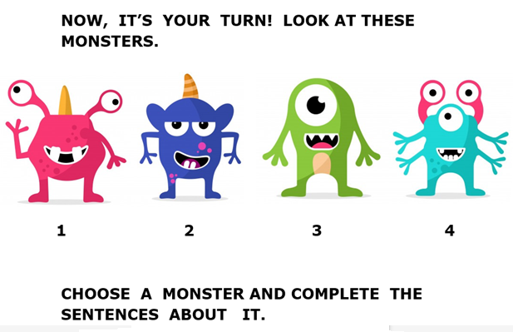

MY MONSTER IS NUMBER …

- THE MONSTER IS …

- THE MONSTER HAS GOT …

- THE MONSTER HAS GOT …

- THE MONSTER HAS GOT …

- THE MONSTER HASN’T GOT ... IT HAS GOT …

- THE MONSTER HASN’T GOT … IT HAS GOT …

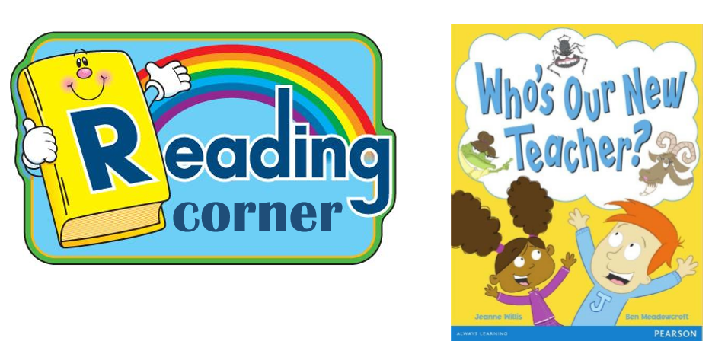
corner

*DO YOU REMEMBER SOME OF THE CHARACTERS IN ‘WHO’S OUR NEW TEACHER? ‘

CTRL + CLICK AND PLAY THIS GAME!
https://es.educaplay.com/recursos-educativos/6646999-who_s_our_new_teacher_charact.html
CTRL + CLICK AND DO THIS WORKSHEET!
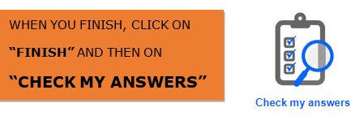
https://www.liveworksheets.com/vh1163921vu

YOUR SCORE: …
