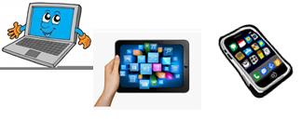
Name: …
Surname: …
Home Schooling 68
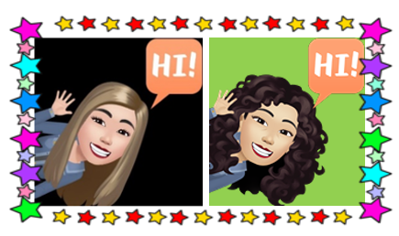

LOOK AT THIS PICTURE. READ, GUESS AND WRITE. REMEMBER TO START WITH 'IT'S A ...' OR 'THEY'RE ...'
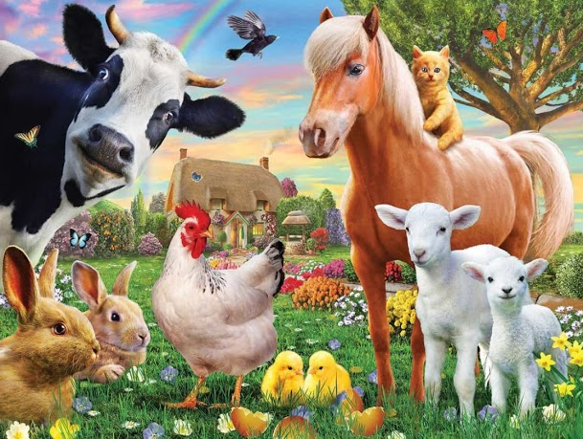
EXAMPLE:
IT’S BLACK AND WHITE. IT’S SMALL. IT’S GOT FEATHERS
IT’S A BIRD.

- IT'S BIG AND BROWN. IT'S ASLEEP AT NIGHT. IT CAN RUN VERY FAST.
IT’S A …

- THEY'RE SMALL AND WHITE. THEY'VE GOT BIG EARS.
THEY ARE …

- THEY'RE SMALL AND BROWN. THEY'VE GOT LONG EARS. THEY CAN JUMP.
…

- IT'S BIG. IT'S BLACK AND WHITE. IT'S GOT HORNS. IT'S AWAKE IN THE DAY.
…

- IT'S SMALL AND WHITE. IT'S GOT 2 LEGS AND WINGS. IT'S GOT 2 YELLOW CHICKENS.
…

NOW GO ONLINE

CTRL + CLICK TO GO ONLINE :
https://forms.gle/SM9Xp6E4okvaW5nR6
