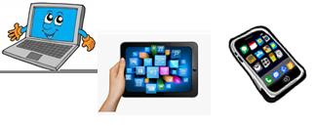
Name:…
Surname: …
Home Schooling 18
Today we continue working on unit 1 of Superminds.

- Follow the link and work on exercise 1 of page 13 from Superminds.
CLICK HERE: https://es.liveworksheets.com/mz423942nk
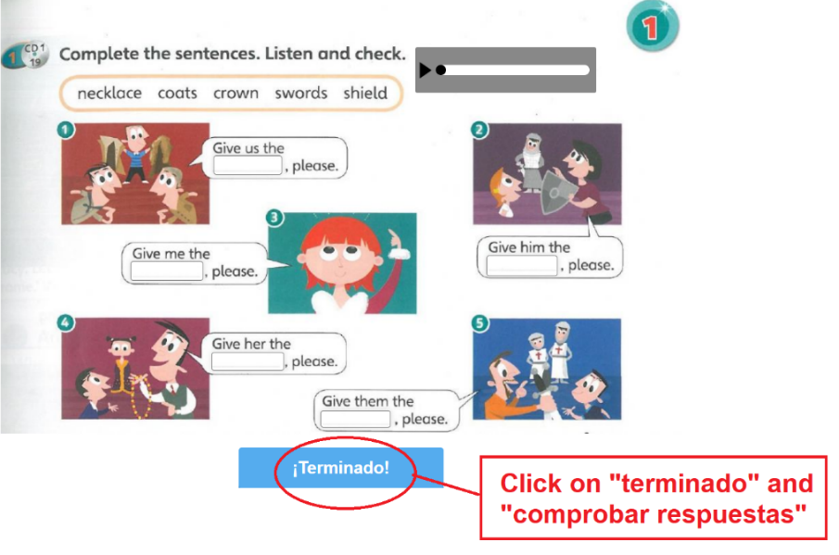

Press ctrl and click to listen to the audio file:
https://bit.ly/2LgSTRK
- Listen and say.

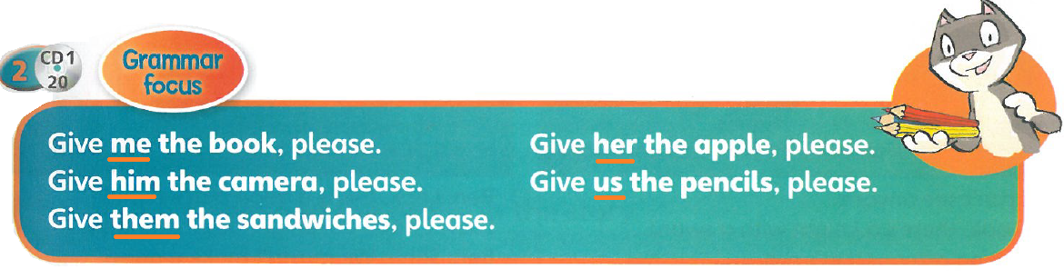

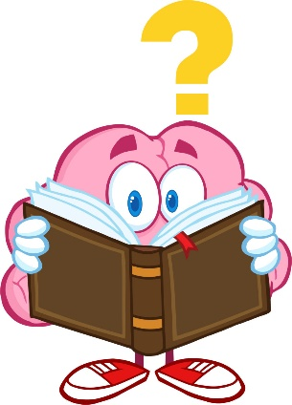
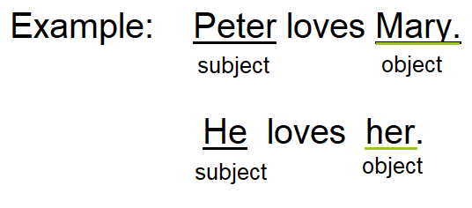
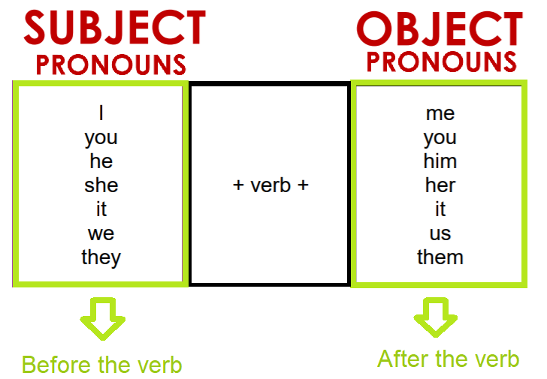
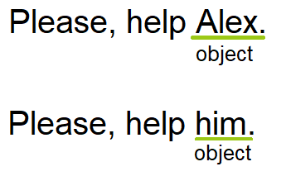
- Read carefully.

We use PRONOUNS to talk about things or people.

  - SUBJECT PRONOUNS come before the verb. (The person who does the action)
  - OBJECT PRONOUNS come after the verb. (The person who receives the action)

- Look at the example and then complete with the correct pronoun.
Example:
Mark sings to Jane. He sings to her.
Jane loves Mark. She loves him.

Tom likes ice-cream. … likes …

Look at Gary and Jason! Look at …! They are angry!

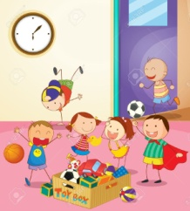 | The children are playing with their toys … are playing with …  Nick can fly the kite … can fly …
These presents are for me and you. These presents are for …

Sophie gives a present to Kelly. She gives a present to …

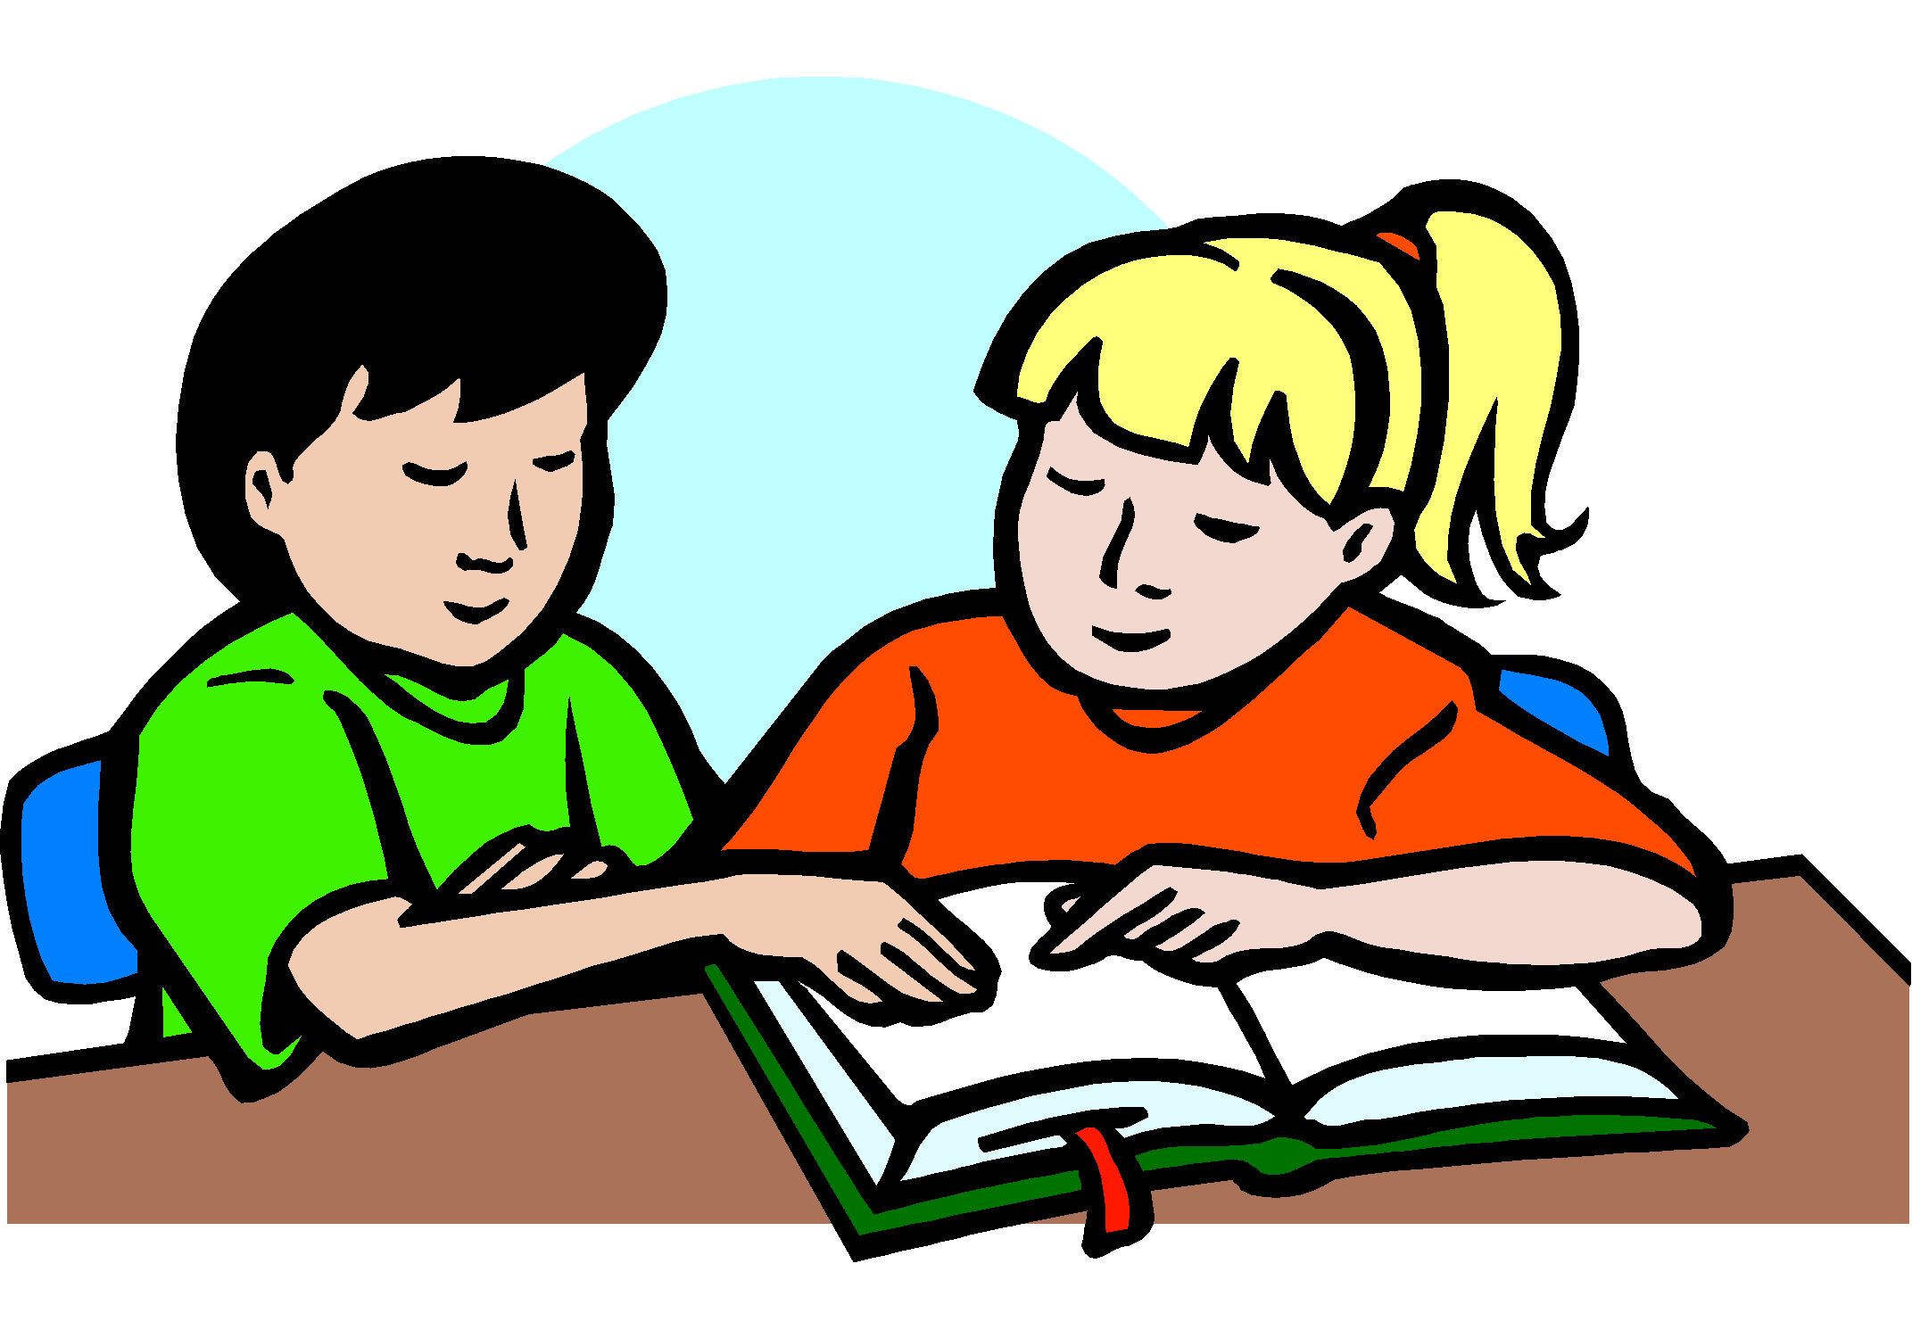 | Can you help … with my homework Steve?  Ben, can you sing with …?
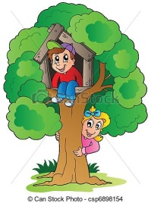 | Dave and Mary can climb the tree. … can climb …

This is the end of your file. Check you have solved all the activities, save your work and send it to your teacher via email:
4th Girls and Boys: msgabygar@gmail.com

NOW GO ONLINE

CLICK AND WORK ONLINE:
https://forms.gle/AWvaY2rbsjd9QLRX9

PLEASE PRESS “SUBMIT/SEND” AT THE END OF YOUR ONLINE WORK
POR FAVOR PRESIONAR “ENVIAR” AL FINAL DEL TRABAJO EN LINEA

