Name:…
Surname: …
Home Schooling 26
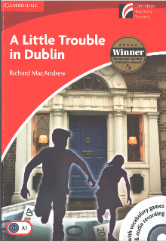
Today we’ll work with chapter 2 of our reader “A Little Trouble in Dublin”

- Do you remember this conversation from chapter 1 (page 9)?
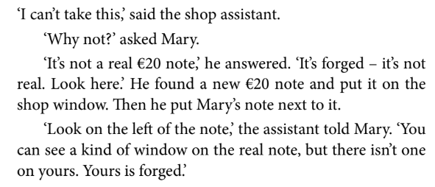
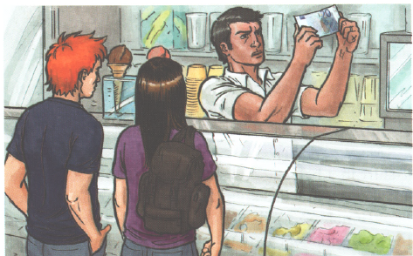
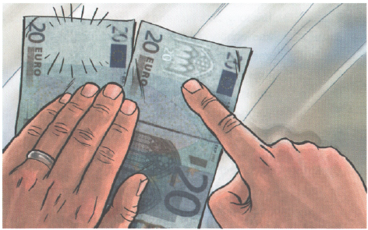

- Where are they? …
- What happened? …

- Read or listen to chapter 2 (page 12). You can use your book or the pdf version.

PDF file: https://bit.ly/3czAvQ0
AUDIO UNIT 2: https://drive.google.com/file/d/1rJcYBZ2ah0mR0N2FDjw1fd9MQs30XCfl/view?usp=sharing
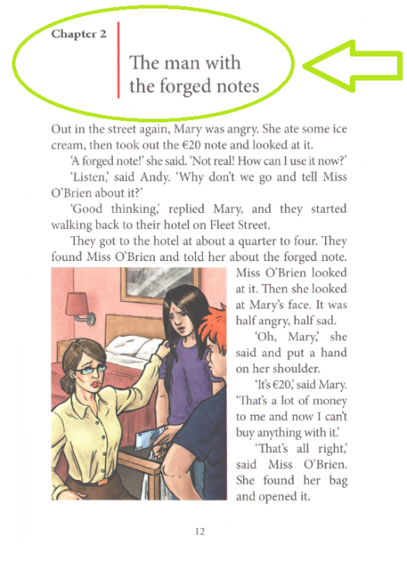

- Let’s work online!
NOW GO ONLINE

CTRL+CLICK AND WORK ONLINE:
https://forms.gle/bCoLJuFGdjuxADji9
PLEASE PRESS “SUBMIT/SEND” AT THE END OF YOUR ONLINE WORK
POR FAVOR PRESIONAR “ENVIAR” AL FINAL DEL TRABAJO EN LINEA

After working online, come back to this file to solve the following exercise

- Let’s check! Play this game!
Click on this link https://www.educandy.com/site/resource.php and enter this code: 223af then press SUBMIT
...

Answer! Use your own words.
- What do you think there is inside the box?
...

- What do you think happens in chapter 3?
...

This is the end of your file. Check you have solved all the activities, save your work and send it to your teacher via email:
4th Boys: msmicaelaferrero@gmail.com
4th Girls: msgabygar@gmail.com

