Name: Surname:
Home Schooling 63
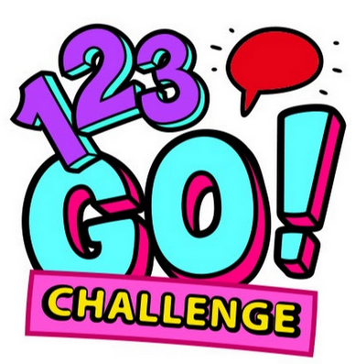
Are you ready?

Challenge 1:
CLICK ON THE LINK:
https://www.gamestolearnenglish.com/perfect-tense-game/
What’s your score?...

Challenge 2:
CLICK ON THE LINK:
https://www.englishpage.com/verbpage/verbs12.htm

What’s your score?...

---------
SKILLS 19B:
You will hear a teacher telling her class about a school trip.
For each numbered gap, fill in the missing information.
Press ctrl and click to listen to the audio file:
https://bit.ly/3nMZ41Z

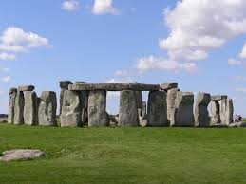
School Trip to: Stonehenge
The place was studied in the 1- … class
Near Salisbury, where the cathedral was built between 2- … and 3- …
The trip will be next 4- …
Parents have to complete a 5- …
Students should return it by the end of next 6- …

PLEASE PRESS “SUBMIT/SEND” AT THE END OF YOUR ONLINE WORK
POR FAVOR PRESIONAR “ENVIAR” AL FINAL DEL TRABAJO EN LÍNEA
This is the end of your file. Check you have solved all the activities, save your work and send it to your teacher via email:
Ezequiel: mrlavena7th@gmail.com
Gisela: msgisela7th@gmail.com
Florencia:msflorz7th@gmail.com
Camila:mscamila7th@gmail.com

